Ideation Phase

Define the Problem Statements

Date | 31 Jan 2026
Team ID | LTVIP2026TMIDS37875
Project Name | Heart Disease Analysis
Maximum Marks | 2 Marks

Customer Problem Statement Template:

Customer: Cardiologist / Healthcare Analyst

Statement:
Cardiologists and healthcare analysts need a fast and reliable way to analyze patient health data and identify heart disease risk early, because current methods are time-consuming, data is scattered across multiple systems, and manual analysis makes it difficult to detect hidden patterns and make quick clinical decisions

.Cardiologists who handle large volumes of patient records struggle to quickly assess heart disease risk due to fragmented data sources, lack of clear visual insights, and time pressure for clinical decision-making. This leads to delayed diagnosis, reduced efficiency, and difficulty in planning timely treatment.

A centralized, intelligent, and easy-to-use dashboard is required to provide real-time risk prediction, visual analytics, and decision support.Healthcare professionals need a way to quickly predict and visualize heart disease risk because patient data is distributed across multiple sources and manual analysis is slow, which results in delayed diagnosis and difficulty in making timely treatment decisions.

Problem Statement (PS) I am… I’m trying to… But… Because… Which makes me feel…

PS- 1
A
cardiologist
Identify high-risk heart disease patients early
The patient data is scattered across multiple reports
There is no unified dashboard with clear visual insights
Frustrated and concerned about delayed diagnosis

PS- 2
A healthcare analyst
Analyze heart disease trends across different demographics
The datasets are large and difficult to interpret manually
Traditional tools don’t provide interactive visualizations
Overwhelmed and inefficient

PS- 3

PS- 4
A hospital administrator
A general patient
(health-conscious | personal heart | complex and hard | to | friendly | interface for | about my health
user) | disease risk | interpret |  | insights |  | status

Make data-driven decisions to improve patient care
Understand my
I cannot quickly see key performance and risk indicators
Medical data is
Reports are static and time-consuming to generate
There is no simple, user-
Uncertain about planning and resource allocation
Anxious and confused

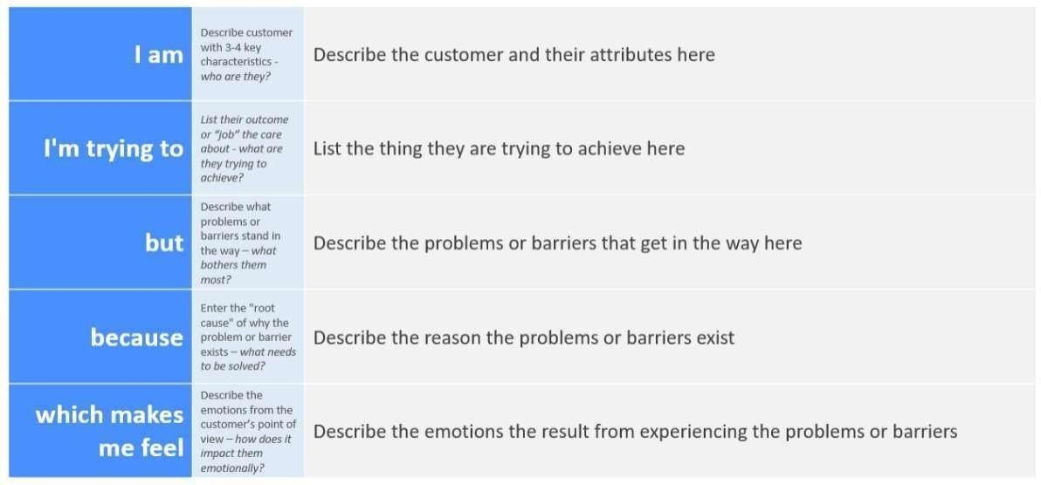

Example: A cardiologist in a multi-specialty hospital
2.2 EMpathy map
